Fitness Class Schedule – [Your Gym/Studio Name]
Week of [Date Range]
Time | Monday | Tuesday | Wednesday | Thursday | Friday | Saturday | Sunday
6:00-7:00 | Yoga | HIIT | Pilates | Yoga | Spin | Open Gym | Closed
7:15-8:15 | Spin | Yoga | CrossFit | Pilates | Zumba | Yoga | Closed
8:30-9:30 | Zumba | Pilates | Yoga | HIIT | CrossFit | Spin | Open Gym
9:45-10:45 | CrossFit | Spin | Zumba | Yoga | HIIT | Zumba | Yoga
11:00-12:00 | Open Gym | Open Gym | Open Gym | Open Gym | Open Gym | Pilates | Spin
12:15-1:15 | Pilates | Zumba | Spin | CrossFit | Yoga | CrossFit | Closed
1:30-2:30 | HIIT | CrossFit | Yoga | Zumba | Spin | HIIT | Closed
2:45-3:45 | Yoga | HIIT | Pilates | Yoga | Zumba | Yoga | Closed
4:00-5:00 | Spin | Yoga | CrossFit | Pilates | HIIT | Spin | Closed
5:15-6:15 | Zumba | Pilates | Yoga | HIIT | CrossFit | Zumba | Closed
6:30-7:30 | CrossFit | Spin | Zumba | Yoga | HIIT | Yoga | Closed
7:45-8:45 | Open Gym | Open Gym | Open Gym | Open Gym | Open Gym | Open Gym | Closed

Class Descriptions:
Yoga: A relaxing practice focusing on flexibility and breath control.
Spin: A high-energy cycling class that burns calories fast.
Pilates: Strength training with a focus on core muscles.
Zumba: A fun dance workout for all fitness levels.
HIIT: High-Intensity Interval Training for building strength and endurance.
CrossFit: A challenging full-body workout.
Open Gym: A time for self-directed workouts.

Instructors:
Yoga: [Instructor Name]
Spin: [Instructor Name]
Pilates: [Instructor Name]
Zumba: [Instructor Name]
HIIT: [Instructor Name]
CrossFit: [Instructor Name]

Notes:
Please arrive at least 10 minutes before class starts.
Booking in advance is recommended.
Classes are subject to change.
For booking and more information, please visit our website or contact us at [Your Contact Information].

This template can be further customized according to your needs. If you’re looking for a professional software solution to manage your fitness classes schedule, bookings, payments, and more, you might consider booking a demo with Exercise.com. We offer a custom-branded fitness app designed specifically for fitness professionals like gym owners and personal trainers, allowing you to run your entire business seamlessly.

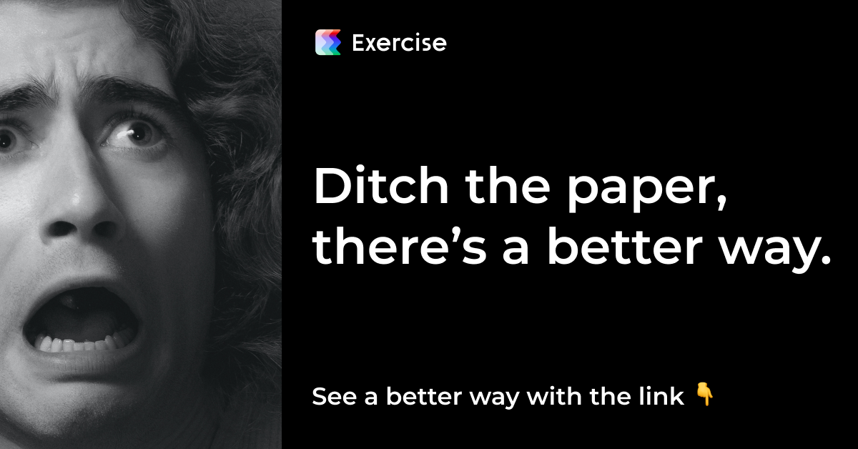
Click me, it’s worth it. I promise.

