Fitness Assessment Template

Client Information:

Name: ___________
Age: _____________
Gender: __________
Contact Information: __________
Occupation: __________
Emergency Contact: __________
Health and Medical History:

Current Medications: __________
Previous Injuries/Surgeries: __________
Known Allergies: __________
Chronic Health Conditions: __________
Family History of Health Issues: __________
Fitness Goals:

Primary Goals (e.g., weight loss, muscle gain): __________
Secondary Goals: __________
Target Timeframe: __________
Lifestyle Information:

Smoking/Alcohol Consumption: __________
Diet Preferences/Restrictions: __________
Sleep Patterns: __________
Stress Levels: __________
Current Physical Activity:

Exercise Frequency: __________
Exercise Type/Intensity: __________
Favorite Activities/Sports: __________
Limitations/Concerns: __________
Measurements:

Height: ___________
Weight: ___________
Body Mass Index (BMI): ___________
Body Fat Percentage: ___________
Waist Circumference: ___________
Hip Circumference: ___________
Blood Pressure: ___________
Strength Assessment:

Push-ups (reps): ___________
Sit-ups (reps): ___________
Plank (time): ___________
Squats (reps): ___________
Flexibility Assessment:

Sit and Reach Test: ___________
Shoulder Flexibility Test: ___________
Cardiovascular Assessment:

Resting Heart Rate: ___________
3-Minute Step Test: ___________
12-Minute Run/Walk Test: ___________
Assessment Summary and Recommendations:

Strengths: __________
Areas for Improvement: __________
Personalized Workout Plan: __________
Nutritional Guidance: __________
Follow-up Schedule: __________
Assessor’s Signature:

Name: __________
Date: __________
Signature: ____________________
Client’s Acknowledgment:

Name: ____________________
Date: ____________________
Signature: ____________________
Please note that a fitness assessment should always be performed by a qualified fitness professional, and the above template should be customized according to individual needs and goals. It might also be integrated into a custom branded fitness app like Exercise.com, where fitness professionals can manage various aspects of their business, including client assessments. You can create your own fitness assessments, customize existing fitness assessments, send them out in your own custom branded fitness apps and web platform, and more.

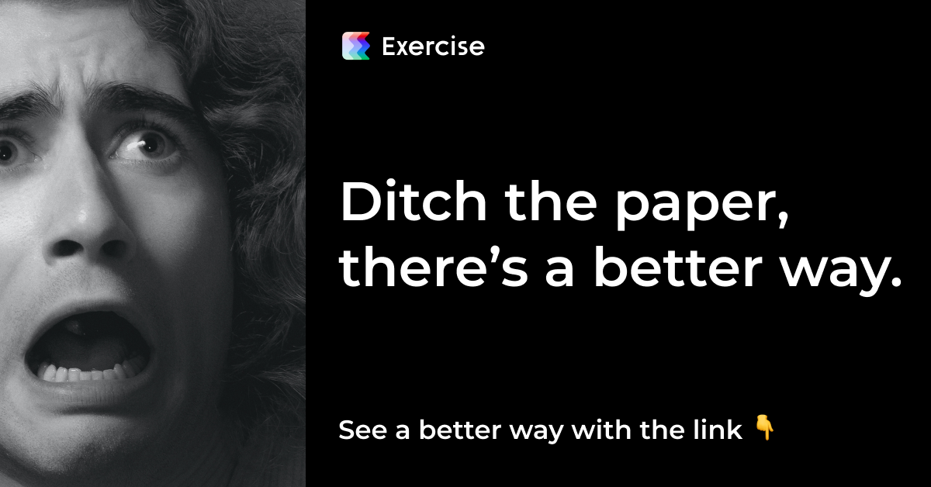
Click me, it’s worth it. I promise.

